CTM-I Use Case

Audit Query

Version 0.1

Use Case Name | Audit Query
Actor | App Support User
Pre-conditions /Assumptions | User has Browser and is aware of the http path to the application.  User has successfully logged into the CTM-I application.  User has the right role to see the menu options.
Post Conditions | None
Screenshot | 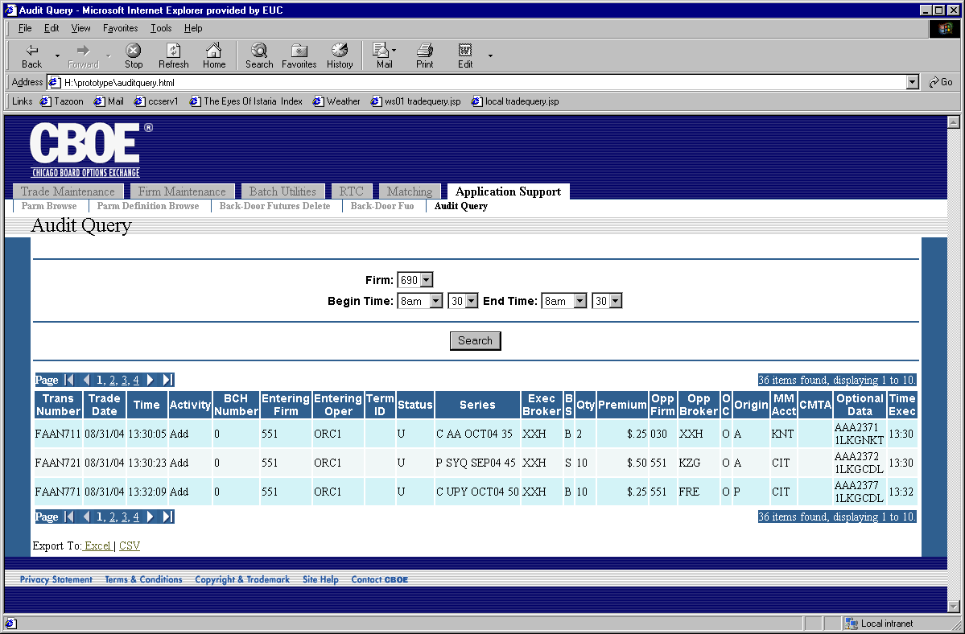
Flow of Events | - User selects “Audit Query” from the menu.  - The Audit Query screen appears  - The screen contains fields that can be used to select audit data to show on the screen  - Firm  - The user may select one firm to filter the data by firm.  - Begin Time  - The user is restricted to valid times between 8am and 8pm.  - End Time  - The user is restricted to valid times between 8am and 8pm.  - The search button will be available to submit the search  - The search will be sent to CTM-R and the results displayed.  - Search results will contain the following fields  - Transaction Number  - Trade Date  - Time of Entry  - Activity  - BCH Number  - Entering Firm  - Entering Operator  - Terminal ID  - Status  - Series  - Executing Broker  - Buy/Sell  - Quantity  - Premium  - Opposite Firm  - Opposite Broker  - Open/Close  - Origin  - Market Maker Account  - CMTA  - Optional Data  - Time of Execution  - Only 10 results will show on the page.  - The standard paging mechanism for tables will be present to page through the data  - The ability to export to Excel and comma separated values (CSV) will be present.
Alternative Path | 4.1.1 If CTM-R returns an error, or no results, the user will be informed of the error.

